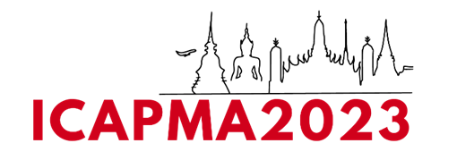

ABSTRACT TITLE (Time New Roman 14)

First Name1, Second Name2, Third Name3,*

1Author affiliations (Department, institution, address-city and country)

2Author affiliations (Department, institution, address-city and country)

3Author affiliations (Department, institution, address-city and country)

*\*Email:* [*xxxxx@xxxxx.com*](mailto:xxxxx@xxxxx.com)

**Abstract (Time New Roman 12)**

Abstract text should be in Times New Roman of 12 point and one line below the last affiliation. It must not exceed about 1 page (total) in Times New Roman of 12 point.

**Keyword:** 3~5 key words in common usage should be included. Multiple keywords should be separated by a comma.